Over The Wire

## Level 17 to Level 18

**Step 1: SSH Login**

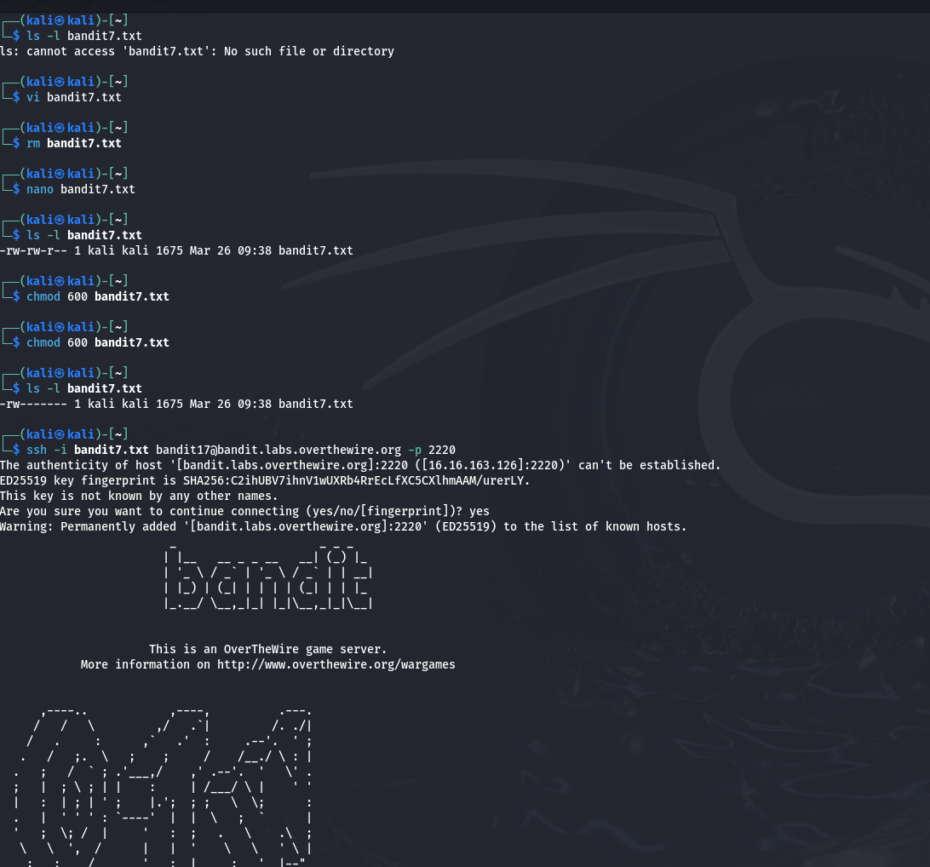

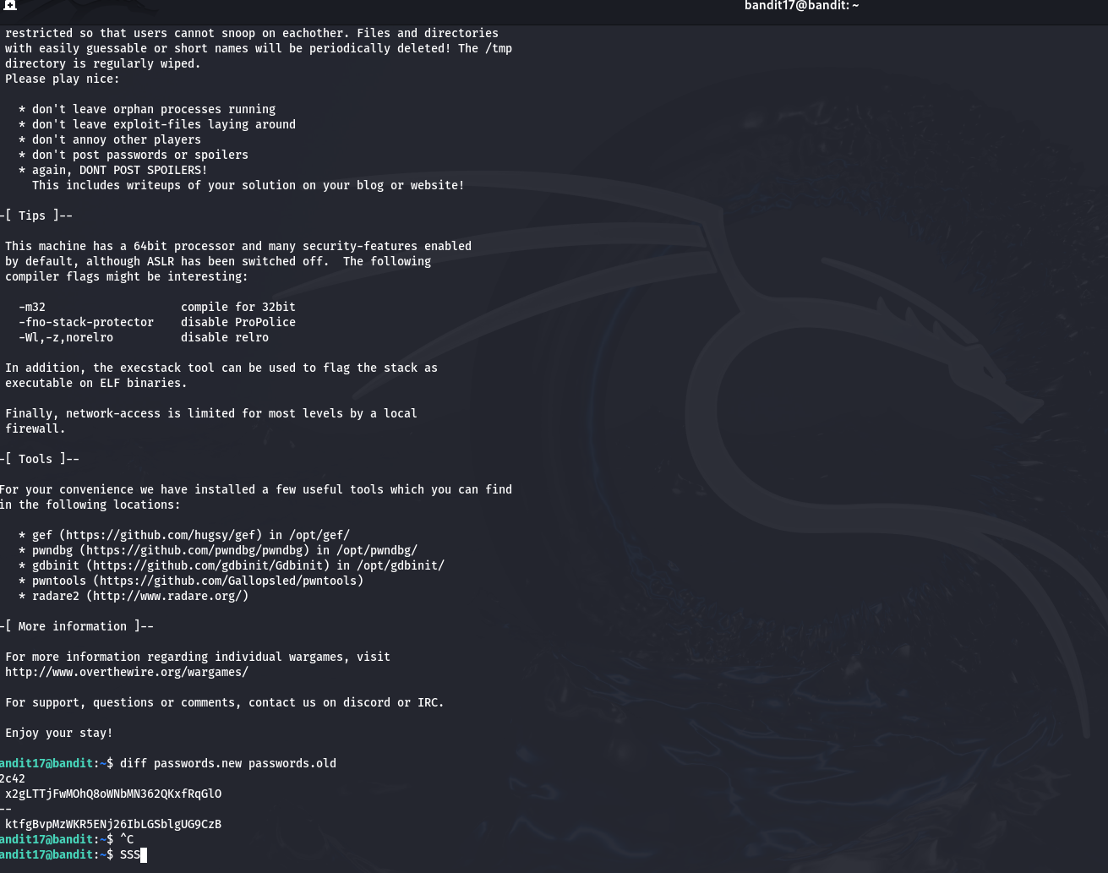

**bandit17@bandit:~$ diff passwords.new passwords.old**

**42c42**

**< x2gLTTjFwMOhQ8oWNbMN362QKxfRqGlO**

**---**

**> ktfgBvpMzWKR5ENj26IbLGSblgUG9CzB**